SÅDAN GØR VI!
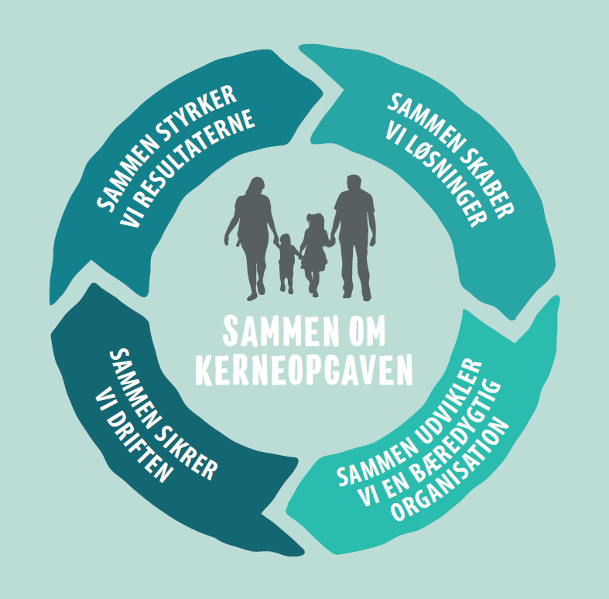
Afdeling/Institution/Gruppe:______________________________________________________
__________________________________________________________________________________________________________________________________________________________________________________________________________________________________________________________________________________________________
_______________________________________________________________________________________________________________________________________________________________________________________________________________________________________________________________________________________________________________

________________________________________________________________________________________________________________________________________________________________________________________________________________________________________________________________________________________________________________
_______

__________________________________________________________________________________________________________________________________________________________________________________________________________________________________________________________________________________________________

